Customer Segmentation Using SQL, RFM, and K-Means Clustering
Online Retail II – 2010–2011
Prepared by: Karthik
Tools: SQLite, Python, Pandas, Scikit-Learn, Matplotlib, Seaborn
1. Executive Summary
The Online Retail II dataset contains over 500,000 e-commerce transactions from 2010–2011.
This project builds an end-to-end customer segmentation workflow using:
- SQLite for data cleaning
- SQL RFM feature engineering
- Python K-Means clustering
- Data visualization for business interpretation
Four customer segments were identified:
- VIP Ultra-High-Value Customers
- High-Frequency Mid-Value Customers
- Moderate Buyers
- At-Risk Low-Value Customers
These segments support personalized retention campaigns, targeted marketing, and revenue optimization.
2. Dataset Overview
The dataset includes:
- Invoice number
- Product code (StockCode)
- Description
- Quantity
- Unit Price
- Timestamp (InvoiceDate)
- CustomerID
- Country
Raw Schema in SQLite
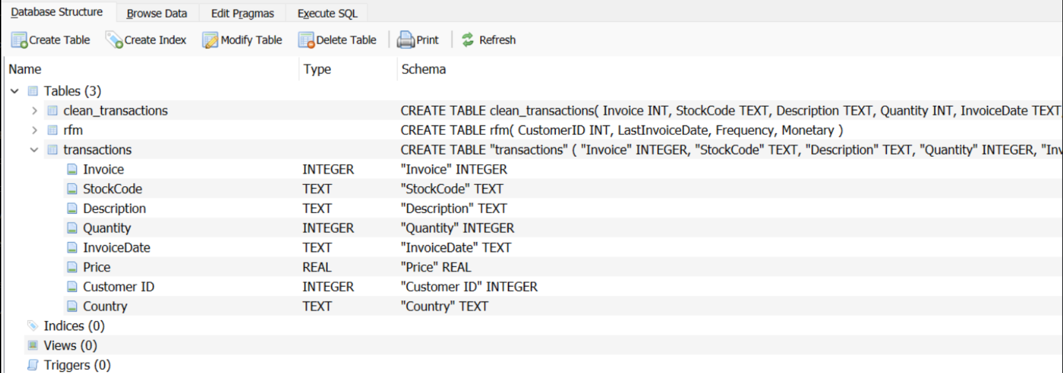
The raw dataset required extensive cleaning due to:
- Cancelled invoices
- Negative quantities
- Missing customer IDs
- Zero or negative prices
3. SQL Data Cleaning & Engineering
3.1. Creating Clean Table
Cleaning steps:
- Clone transactions → clean_transactions
- Remove cancelled invoices (Invoice LIKE 'C%')
- Remove negative quantities
- Remove negative/zero prices
- Drop NULL CustomerIDs

Sample of Cleaned Transactions
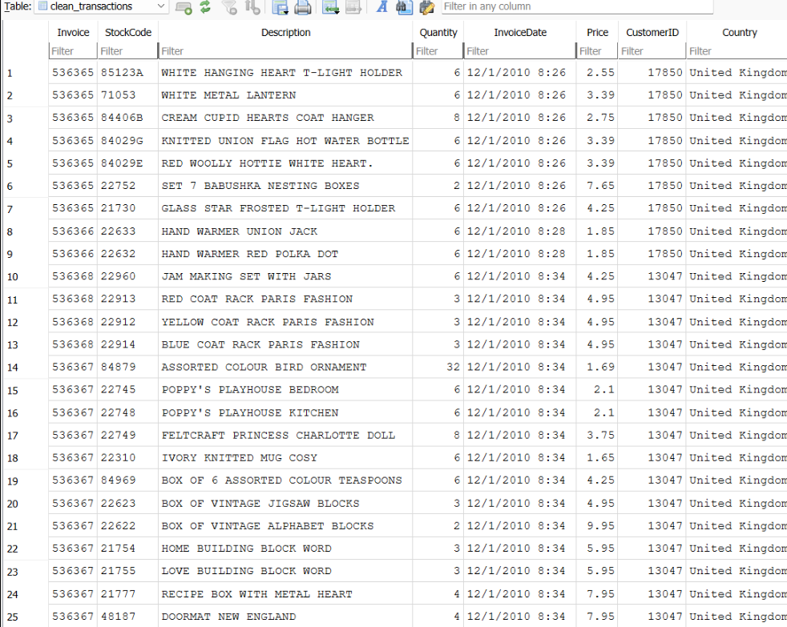
3.2. Constructing RFM in SQL
SQL used to create customer-level RFM metrics:
CREATE TABLE rfm AS
SELECT
CustomerID,
MAX(InvoiceDate) AS LastInvoiceDate,
COUNT(DISTINCT Invoice) AS Frequency,
SUM(Quantity * Price) AS Monetary
FROM clean_transactions
GROUP BY CustomerID;
Sample of Final RFM Table
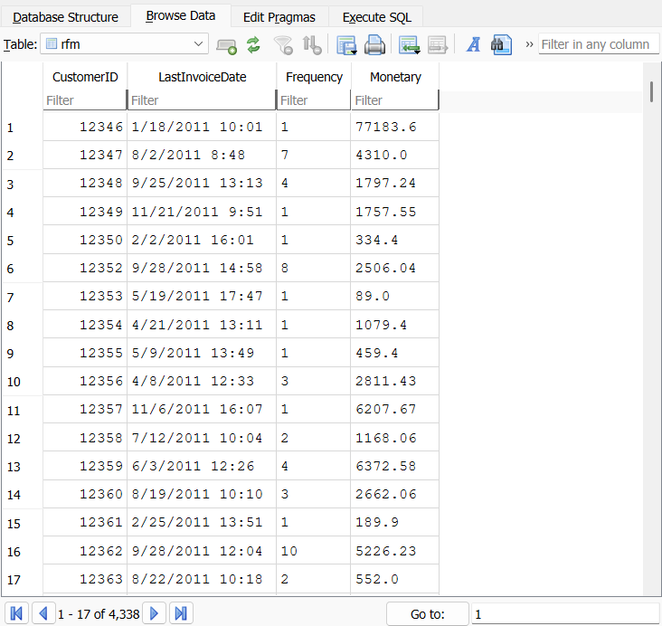

4. Python Modeling & K-Means Clustering
4.1 Preparing Data in Python
- Convert LastInvoiceDate to datetime
- Compute Recency = snapshot_date – LastInvoiceDate
- Extract R/F/M features
- Scale using StandardScaler
- Determine optimal K using Elbow Method
4.2 Elbow Curve Screenshot
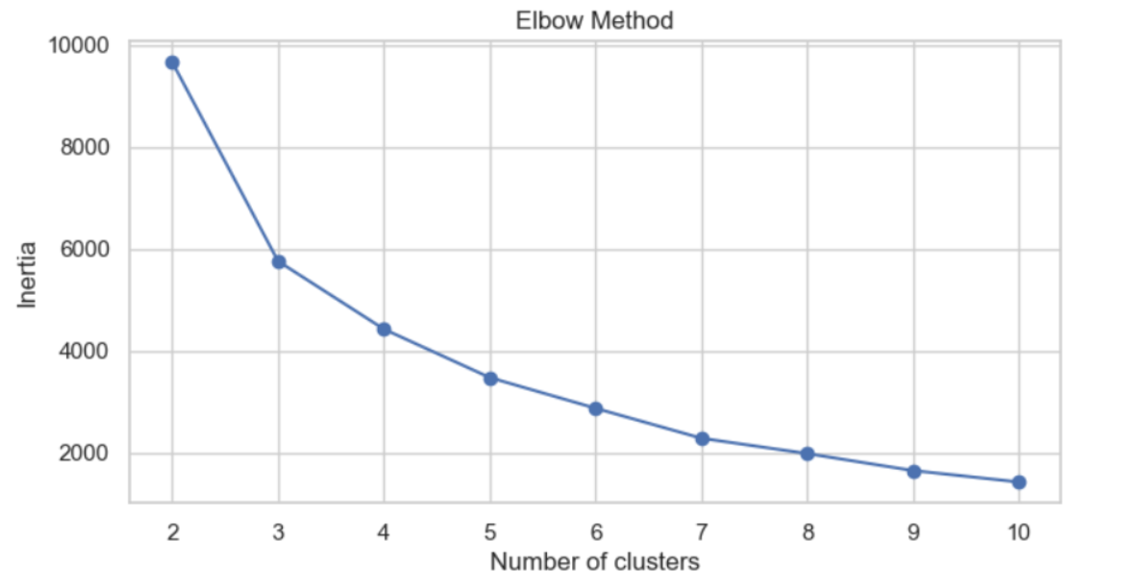
5. Cluster Profiles & Business Interpretation
Cluster centers reveal:
Cluster | Recency | Frequency | Monetary | Insights
0 | Very high | Very low | Very low | At-Risk / Churn
1 | Low | Moderate | Moderate | Occasional Buyers
2 | Medium | High | High | High-Frequency Engaged
3 | Medium | Extremely High | Extremely High | VIP / Elite
Radar Chart Visualization
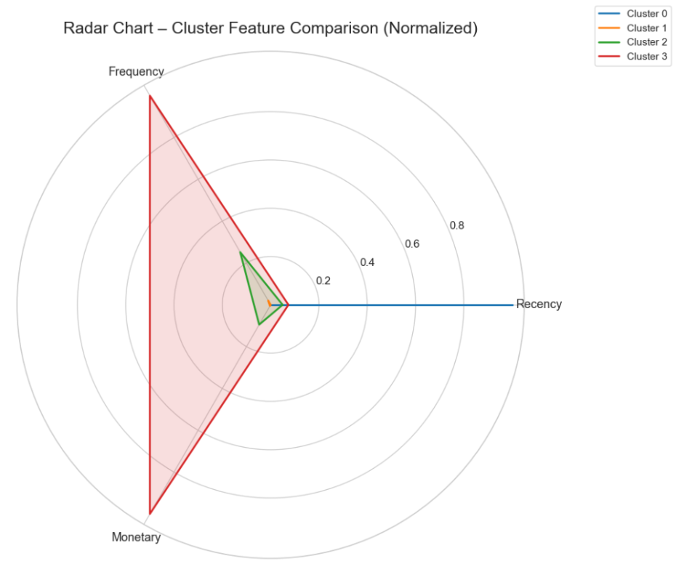
This visualization clearly illustrates segment separation.
6. Customer Personas & Strategies
Cluster 3 – VIP Ultra-High-Value Customers
- Extremely high spend & frequency
- Loyal and engaged
Recommended Actions:
- VIP loyalty tier
- Priority shipping
- Personalized concierge support
- Early product access
Cluster 2 – High-Frequency Mid-Value Customers
- Frequent purchases
- High lifetime value potential
Recommended Actions:
- Cross-sell bundles
- Personalized product recommendations
- Monitor for behavior drop-offs (early churn detection)
Cluster 1 – Moderate Buyers
- Reasonably recent activity
- Moderate frequency
Recommended Actions:
- Targeted email promotions
- Repeat-purchase incentives
- Awareness campaigns
Cluster 0 – At-Risk Low-Value Customers
- Large gap since last purchase
- Minimal frequency or spend
Recommended Actions:
- Low-cost win-back campaigns
- Exclude from expensive channels
- Gentle reminders & coupons
7. Business Impact
This segmentation empowers the business to:
- Increase ROI through hyper-targeted promotions
- Improve customer retention
- Reduce churn
- Prioritize high-value customers
- Optimize discount allocation
- Build long-term CLV-focused profitability
8. Future Enhancements
Potential extensions:
- Predictive CLV modeling
- Cohort analysis
- Basket analysis
- Automated segmentation pipeline
- Tableau / Power BI dashboard
- A/B testing of cluster-based campaigns

Dataset - https://archive.ics.uci.edu/dataset/502/online+retail+ii

